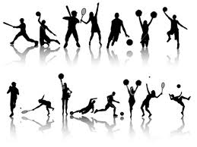

7/8th Grade Physical Education with Coach Kastorff 2014-2015

T
Performance that Earns a Spot
on the Bench Looks Like:
*Tardies
*not properly dressed for PE (- ½ pts )
*not doing warm ups 100%
*Standing around during game time
*talking during instructions
*misuse of equipment
*negative talk & put downs to teammates and teachers
*complaining, whining, excuses
*arguing
*food and/or gum in locker room or on field
*Not giving 100% in game, to team
*Not using common sense
All Star Performance Looks Like:

*Dressed in PE uniform daily
*Leading warm ups
*Helping others learn a skill
*proper use of equipment
*100% effort
*being positive to teammates
*Team work
*sportsmanship
*Hustles to and from activities
*Improves performance daily
*Improves physical fitness daily
*helps bring in equipment
* Use of Common sense
E
A
M

S
P
O
R
T
S

Grading
Daily Play:  *Mastery performance  of the standards (see www.Sandi.net under Physical Education for more info)  *Warm ups (complete participation)  *Practice drills & skills  *Game participation  *Uniforms are on  *Removal from class for discipline reasons = ZERO for day | Fitness Testing  *Mile Run *20 Min Run *Pacer Run  *Muscle Building Exercises / Circuit Workouts / Fitness Gram  *Times / Reps / Scores will be recorded by YOU and me.  *Improvement in endurance & strength comes from your daily effort of working hard to improve.  *The goal is to improve weekly. The more effort you give EVERY day, the “easier” it gets because you get stronger!! | Written Work  * Run test Journal Logs  *Signed syllabus  *reflections  *homework (occasionally)  *team work game planning  (plays, strategies, etc)  *Misc. Written Work  *Nonsuit writing assignments  *Injury / illness assignments  *Absent on Contract
4 days a week x 10 pts daily | 1 day a week (points vary)- make it count! | Ongoing
70 % | 20% | 10%

`Student Initial: _______________
Citizenship – The PE Department follows the CPMA Citizenship Rubric. Please see your planner for more details. Your PE Uniform: CPMA Shirt & Shorts (or sweats) and athletic shoes. That’s IT!!!! Plain / solid blue or gray attire is acceptable but must be free of logos and have student’s name written on them. Student Initial: _______________

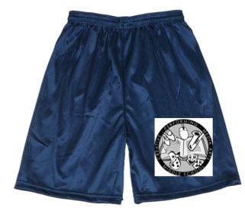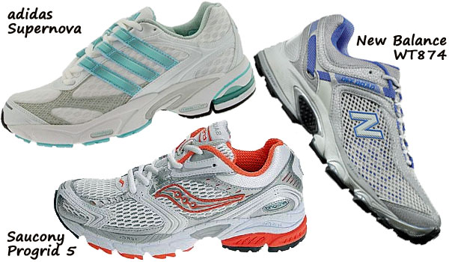
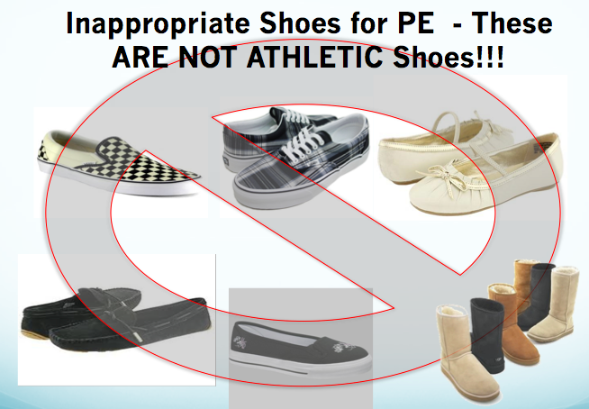

These shoes ARE NOT athletic shoes. They provide no support to your foot or ankle and are not designed to run, jump, kick, etc in. IF THEY CANNOT LACE UP TIGHT, THEY ARE NOT APPROPRIATE FOR PE CLASS. They are lounging shoes. You will sit out the day’s activities or be relegated to walking laps only if you wear these to PE. Limited “loaner” shoes are available for emergencies. Lockers are for storing shoes that you wear 4 days a week, for 35+ weeks a year.

LOANERS: Every day you do not have your PE clothes and need a loaner, you LOSE points off of your daily earned score. That means a 50% for the day before you even start! It is your homework.
After the 3rd loaner, you get a call home, lunch detention, & citizenship drops one letter. You will not be given loaners for the remainder of the grading period after #3. Student Initial: _______________

Tardies: You can be late TWICE to PE: If you are not through the PE gates and in line when the bell rings, AND if you are late getting out to the roll call numbers when leaving the locker room (ie: if you arrive to them after I do). You have ten minutes to change, use the bathroom and get out there. No excuses! RUN if you must, it’s PE! Student Initial: _______________

*This paper is to be kept in your school binder under your PE tab. There will be more to come! There will be surprise “binder checks” to see if you still have this through out the year!*

*This page is to be turned in to Mr. K

Printed name of student: ______________________________________________________________ Period _________

Health Concerns:
Students with asthma are expected to bring their inhalers with them out to PE at all times.

Any injuries or other sudden health conditions that occur throughout the school year need to be reported to Mr. Kastorff before school or in the very beginning of the period as students come through the gate, not at the moment students find out it is time to run and perform).
Student initial: __________

*Only a signed parent note that includes contact information will be accepted as an excuse from a single day’s class. Any issues requiring more than one day’s excuse from class MUST go through the school nurse, per school and district policy. Failure to provide a note will result in loss of points for nonparticipation. Student Initial: _____________

Extreme circumstances may require the student does not “dress out” for PE, participate, or be limited in participation, so this information needs to be shared immediately. Thank you for your support in this. Alternative assignments can be provided for earned credit if we are given the notice we request.
-------------------------------------------------------------------------------------------------------------------------------------------------------------------------------------------------------------------------------------------------------------------------------------------------------------------
Below, please list any current medical issues or limitations your student may have. Please also include any after school sports or activities you participate in. It’s nice to know who my experienced players are, as well as knowing when games are so we can adjust the activities accordingly for them. Student Initial: _______________

I have read and understand the grading policy, rules and expectations of Mr. Kastorff’s Physical Education Class. I know what it will take for me to achieve success in this class and improve my own physical fitness and health over the course of the year and beyond.

Signature of student: _______________________________________________________________________
PRINTED name of guardian: ______________________________________________________________

Signature of Guardian: ____________________________________________________________________

Email: _________________________________________________________________________________________

Daytime Phone: _____________________________________________________________________________

Evening Phone (if different): ______________________________________________________________

Thank you and we look forward to a fun and exciting year in CPMA’s Physical Education department!
Coach K jkastorff@sandi.net - email is the easiest way to contact me.

